Submission on the National Recovery and Resilience Plan
February 2021

Introduction
The Covid-19 pandemic exposed many of the underlying structural weaknesses in our economies and societies, with the most marginalised and vulnerable at greatest risk from the disease. While for some, the message to “stay at home” meant remaining in a place of safety and sanctuary, for others it meant isolation, abuse, overcrowding, or rough-sleeping.
In considering how Ireland will rebuild and reopen after this pandemic, there is an opportunity to radically alter our approach to public policy in core areas such as housing. Covid-19 was, rightly, addressed as a public emergency, allowing for sweeping changes, the introduction of a moratorium on evictions, and the rapid housing of households who would otherwise likely still be trapped in emergency accommodation. While the ending of the emergency will limit some of the legal powers the Government currently holds, we must not allow a regression in how we treat the most vulnerable in our society. Every case of homelessness is an emergency for the individual or family facing rough sleeping, sofa surfing, or entering emergency accommodation. A society facing high levels of homelessness, rising rents, unaffordable housing and a severe undersupply of construction is a society facing an emergency. Homelessness and housing insecurity leaves people vulnerable to poor health outcomes, shorter life expectancy, social isolation, poverty, mental health problems and addiction. For children, it leads to developmental delays, difficulty creating and maintaining relationships, poor education outcomes, early school leaving and places them at risk of suffering lifelong mental health difficulties.
The importance of access to stable, long-term housing has become more evident than ever in the wake of a year of lockdown measures. This has been recognised by the Government with the welcome inclusion of the eviction and rent increase moratoriums in the COVID-19 emergency response legislation. These measures, along with a concerted effort by local authorities working with NGOs and AHBs, led to significant reductions in the number of people in emergency accommodation over the past year. While there was a reduction in the overall number of people in emergency accommodation, there was a rise in the number of single people entering homelessness in Dublin, illustrating the work that remains to ensure we reduce the number of people accessing homeless services to functional zero.
While work remains to be done, it is within our grasp to permanently reduce the number of people experiencing the trauma of homelessness across Ireland and to prevent future crises occurring in future. It would be a significant failure if we do not take the opportunity presented by the EU’s Recovery and Resilience Facility to significantly step up our response to homelessness.
As strongly recommended by the European Commission in the Country-Specific Guidance for Ireland, increasing the supply of social and affordable housing is an urgent priority and must be prioritised in our National Recovery and Resilience Plan. This submission will focus on the issues of housing, homelessness and inequality as outlined in point 19 of the Country Specific Guidance 2020.

1. Invest in Social Housing
Ireland’s social housing stock has suffered from underinvestment for over a decade, leading to severe shortages of supply and long waiting lists across the country. The construction sector has been hit hard by Covid-19 and faced long periods of shutdown during 2020, yet still succeeded in providing over 20,000 new units in 2020, just 1.9% lower than in 2019. However, the ESRI have stated that between 30,000 and 35,000 new homes are needed each year to meet demand. The state must invest heavily in increasing its output of social housing, both to overcome the current shortage and to meet the expected demand into the future. Placing the Land Development Agency on a statutory footing provides an opportunity to increase construction of public homes on public lands; however, it is regrettable that currently the LDA has a target for social housing of only 10%. This is the same as current Part V requirements and is not nearly ambitious enough in its use of public lands for public purpose.
By Q3 of 2020, 15,526 social houses had been provided by Local Authorities. However, less than 20% of this was long-term, stable social housing in the form of new builds and acquisitions/leases. The majority of Local Authority provisions are made up of costly subsidies to the private rental market such as HAP and Rent Supplement, which do not provide permanent homes. Similarly, the majority of exits from emergency accommodation continue to be to the Private Rented Sector. While renting is a suitable option for some, it does not offer a stable or permanent exit from homelessness, even when supported by HAP.
For vulnerable, young and low-income households, current restrictions on mortgage lending make it impossible to access finance adequate to facilitate home ownership in the current market. Given the gap between average annual salaries and average house prices, home ownership will not happen for this group in the absence of an affordable housing policy, together with supply-side measures to stimulate construction in the lower-end of the market, without further inflating prices.
Households locked out of the highly competitive private market are either stretching their finances to afford rising monthly rents or they are relying on State subsidies in the form of HAP and rent supplement. Given the gap between HAP rates and market rents, many households on HAP are paying unaffordable top-ups to landlords in order to avoid a further experience of homelessness. This is evidenced by CSO research demonstrating a rise in those at-risk of poverty in the private rental market.
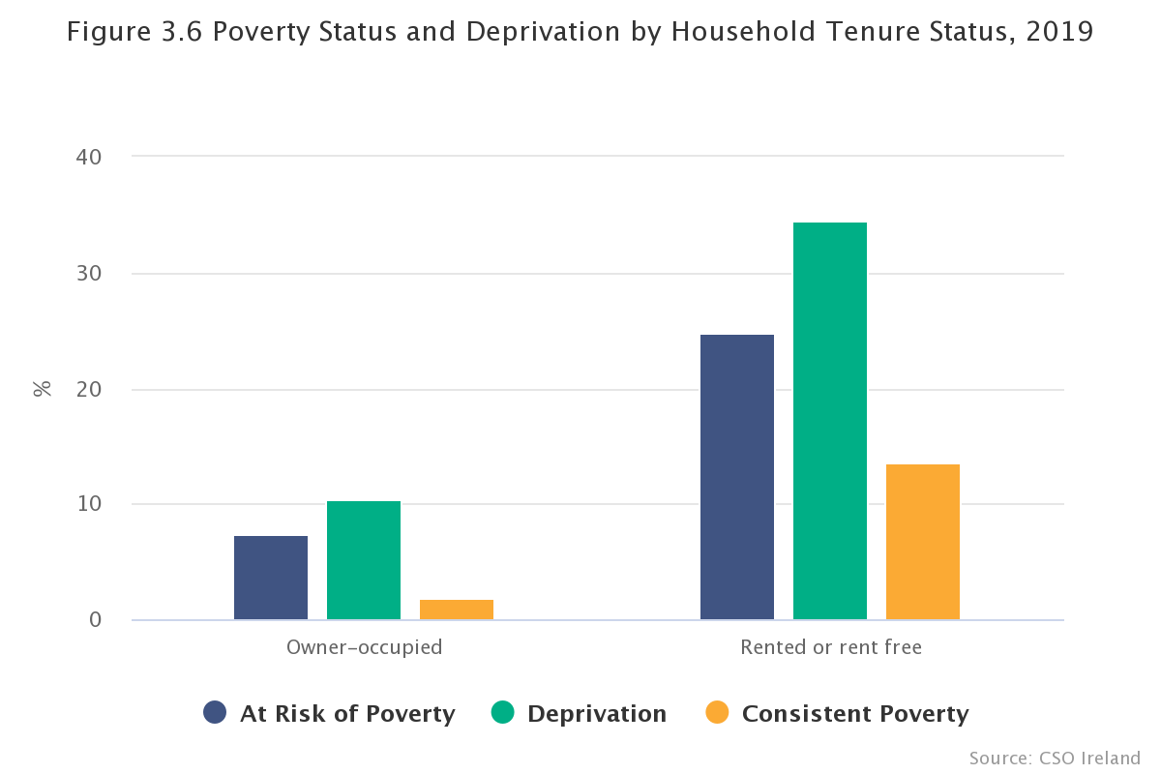

By 2019, the State was supporting 57,630 HAP tenancies with Budget 2021 committing to the creation of a further 15,000 HAP tenancies, at a cost of €560 million. While an important emergency measure to avoid large numbers of people reliant solely on homeless services, the HAP and rent supplement schemes make the State a significant actor in the private rental market. It would be preferable for the State to reduce its presence in the private rental market by providing an alternative of long-term, stable housing for those households who will require public homes. Building social housing is the most cost-effective and reliable way to ensure adequate and secure housing for all not only at present, but for the coming generations.
In rebuilding and reopening our economy and society, we must reconfigure how we conceive of the State’s role in housing. In a modern, globalised world where investment from external actors and funds in other jurisdictions can radically alter and distort our housing market -- without regard for domestic factors, such as earning capacity or mortgage lending requirements -- the State must step in to provide permanent accommodation where the private market will not. One aspect of this is to commit to reaching ambitious social housing targets which will significantly reduce the number of people on the social housing waiting list. Another aspect is to consider the extent to which the common good and public interest is served by allowing our homes to be used as packaged commodities in a manner which fails to recognise the international human right to housing. Focus Ireland believes that the State must recognise and vindicate the right to housing in the Irish Constitution, in recognition of the economic and social necessity of a home for all as a basic social good.

2. Reforming the provision of emergency accommodation
The unsuitability of congregate emergency accommodation settings has been further emphasised by Covid-19. For Family Hubs, many of the problems identified by the Ombudsman for Children’s report from 2019 such as overcrowding and lack of privacy will have worsened in the context of lockdowns, school closures and working from home. Collective action between local authorities, the HSE, NGOs and AHBs in the early weeks of the pandemic meant that social distancing of those in homeless accommodation happened quickly. People with underlying conditions or at high risk of contracting the disease were moved into shielding units. Emergency accommodation moved to 24 hour access, effectively ending the “one night only” policy overnight. The sector has been dealing with the crises of homelessness for years now and the maturity of the crisis provides an opportunity for deep collaboration to drastically reduce the numbers in homeless services over the next five years as we rebuild post-pandemic.
While not counted in the monthly reports published by the Department of Housing, people living in domestic violence refuges are homeless, temporarily offered a form of emergency accommodation. Recent reports show an alarming rise in the incidents of domestic violence during lockdown, along with an increase in child welfare reports to Tusla. Post-pandemic, serious attention must be paid to this at-risk group to ensure that targeted and properly funded supports are in place to ensure that people who need to leave their accommodation as a result of domestic violence are fully supported in this and are diverted out of emergency accommodation wherever possible.
Homeless shelters do not solve homelessness, they are neither a cost-effective nor a long-term solution to the problem. Long-term, sustainable homes must be at the centre of our national housing and homelessness policies.
A recent Focus Ireland report found that the cost per household in emergency accommodation more than doubled between 2014 and 2019. Total expenditure on homelessness grew from nearly €54.9m in 2013 to €226.2 in 2019, and over ¾ of all expenditure over this period went on emergency accommodation. The majority of this increased spend on emergency accommodation is going to private, for-profit accommodation providers. The substantial public funds now spent on simply maintaining the emergency accommodation system must be redirected towards long-term solutions in the form of public homes and affordable housing.
The pressures of the Covid-19 crisis have shown the strength of the Housing First response and the opportunity now arises to lift this from being ‘one programme among many’ to be the underlying approach of our whole homeless system.

3. Links between Public Health, Housing and Inequality
With prolonged periods of working from home becoming the norm for many, there are clear implications for the future stability of the workforce when housing remains so squeezed and rents so high. A low supply of housing forces people to live in overcrowded accommodation which poses difficulties when those people need to self-isolate or limit contacts. Low-income workers are most likely to live in overcrowded accommodation, and are also the most likely to have had frontline jobs throughout the pandemic such as shop staff, factory workers and cleaners.
The higher rate of infection amongst vulnerable groups, including the Traveller community and the Roma community, illustrate the link between public health risks and inadequate housing. Both communities suffer from overcrowding and insecure housing, which led to the spread of the virus at far higher rates than among the general population. Measures were introduced to tackle the risk of the virus to this group; however these measures do not address the longstanding, broader health risks facing these marginalised groups. Learning from the lessons of Covid-19 means that, post-pandemic, we must address the inequality faced by marginalised groups through the targeted provision of appropriate accommodation to ensure better health outcomes.
Those most affected by COVID-19 related job losses are predominantly young, part-time and low-skilled workers. This is also the cohort most likely to live in overcrowded and unstable rented accommodation. As noted by the EU Commission in the Country-Specific Recommendations, the lack of available social housing and the high level of homelessness in Ireland “raises concerns about the potential risks of deepening inequalities, entrenched poverty and social exclusion”. The unequal effects of the pandemic on household income and employment will likely be harshest on those already most vulnerable to housing instability and homelessness. If the shortage of social and affordable housing is not addressed urgently, the gains made during the pandemic of reducing homelessness could quickly be undone. In the absence of a proactive, urgent rise in the construction of social homes, the legacy of Covid-19 may include a deepening of the homelessness crisis. We must make housing central to the National Recovery and Resilience Plan.

Conclusion
Focus Ireland welcomes the opportunity to make a submission to this important public consultation process. We believe that there is an opportunity, post-pandemic, for a more ambitious new direction for Irish society, particularly in the area of housing and accommodation. Our homes are the bedrocks of our lives. Without a home, every aspect of a person’s life becomes secondary, affecting everything from physical and mental health to education and employment attainment. A fair society is one which recognises these inequalities and works to address them. Nowhere is this inequality clearer than in our current housing crisis.

Focus-Ireland-therapeutics-FINAL_01-12-2020-1.pdf
Rental Legislation & Covid-19 | Residential Tenancies Board (rtb.ie)
Latest Figures on Homelessness in Ireland - Focus Ireland
Homeless-Update-No.10.pdf (homelessdublin.ie)
https://www.esri.ie/sites/default/files/media/file-uploads/2019-10/Housing_Committee_October_10_2019.pdf
https://www.gov.ie/en/collection/6060e-overall-social-housing-provision/?referrer=http://www.housing.gov.ie/housing/social-housing/social-and-affordble/overall-social-housing-provision#rebuilding-ireland-progress-against-targets
https://www.gov.ie/en/collection/80ea8-homelessness-data/?referrer=http://www.housing.gov.ie/housing/homelessness/other/homelessness-data#local-authority-regional-performance-reports
Press Statement Social Housing in Ireland - Analysis of HAP 2019 - CSO - Central Statistics Office
gov.ie - Minister O’Brien announces €3.1 billion housing budget (www.gov.ie)
No-Place-Like-Home.pdf (oco.ie)
Pandemic leads to spike in child welfare reports from domestic violence refuges (irishexaminer.com)
https://www.focusireland.ie/focus-on-homelessness-special-editions/
https://www.ihrec.ie/app/uploads/2018/06/Discrimination-and-Inequality-in-Housing-in-Ireland..pdf
Coronavirus ‘disproportionately impacting’ Ireland’s Roma community (irishtimes.com)
IE report-Covid-19 Impact on Roma-FRANET SR 33 (europa.eu)
https://www.gov.ie/en/press-release/97112d-minister-doherty-announces-the-publication-of-a-working-paper-on-the/
https://www.ihrec.ie/app/uploads/2018/06/Discrimination-and-Inequality-in-Housing-in-Ireland..pdf
2020 European Semester: Country Specific Recommendations / Commission Recommendations | European Commission (europa.eu)

